**DAILY ASSESSMENT**

|  |  |  |  |
| --- | --- | --- | --- |
| **Date:** | **18-7-2020** | **Name:** | **Gaganashree P** |
| **Course:** | **salesforce** | **USN:** | **4al15ec024** |
| **Topic:** | **Salesforce user basics** | **Semester**  **& Section:** | **8th A** |
| **Github**  **Repository:** | **Gaganshree-P** |  |  |

|  |
| --- |
| **FORENOON SESSION DETAILS**  C:\Users\Rakesh Kiran M G\Downloads\20200719_221059.jpg |
| **Salesforce user basics**  **Introduction**  Are you new to Salesforce? Not sure exactly what it is, or how to use it? Don’t know where you should start on your learning journey? If you’ve answered yes to any of these  questions, then you’re in the right place. This module is for you. |

Welcome to Salesforce! Salesforce is game-changing technology, with a host of productivity-boosting features, that will help you sell smarter and faster. As you work toward your badge for this module, we’ll take you through these features and answer the question, “What is Salesforce, anyway?”

So let’s start right there.

## What Is Salesforce?

Salesforce is your customer success platform, designed to help you sell, service, market, analyze, and connect with your customers.

Salesforce has everything you need to run your business from anywhere. Using standard products and features, you can manage relationships with prospects and customers, collaborate and engage with employees and partners, and store your data securely in the cloud.

## What Is CRM?

CRM stands for Customer Relationship Management. This technology allows you to manage relationships with your customers and prospects and track data related to all of your interactions. It also helps teams collaborate, both internally and externally, gather insights from social media, track important metrics, and communicate via email, phone, social, and other channels.

In Salesforce, all of this information is stored securely in the cloud. Let's take a closer look at how that works, using an example you might be familiar with a spreadsheet.

## How Salesforce Organizes Your Data

Salesforce organizes your data into objects and records. You can think of objects like a tab on a spreadsheet, and a record like a single row of data.

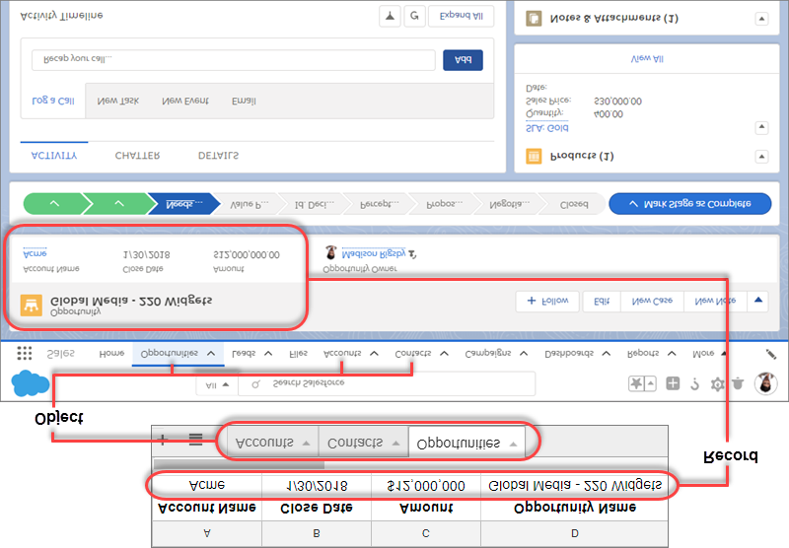

In Salesforce, objects are accessed via the navigation menu. Select any record to drill into a specific account, contact, opportunity, or any other record in Salesforce.

# Get Started with Salesforce

## Welcome to Lightning Experience

Welcome to Lightning Experience! Lightning Experience is a modern, productive user experience designed to help you do more and be more efficient.

With Lightning Experience, we’ve re-envisioned the desktop experience to support your sales and service processes. The result is a more productive interface, designed to support how sales reps and service agents work on a daily basis.

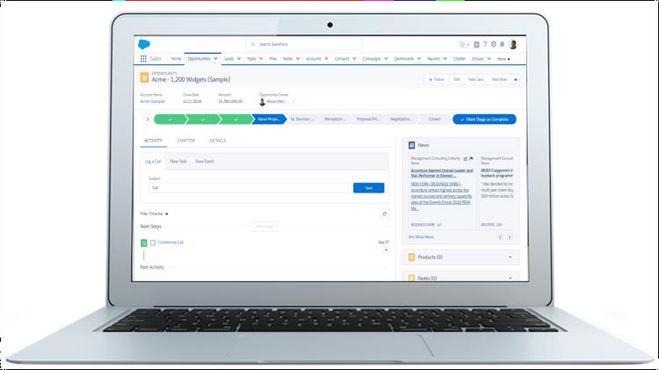

When we’re talking about Lightning Experience, we’re talking about pages in Salesforce optimized for sales and service use. We’re talking about new features that help you focus on the right activities, every time you log into Salesforce. We’re talking flexible, interactive tools that you can use to visualize data on the fly and work deals in flight.

Want to know more? Let’s start by getting you logged in.

## Log in to Salesforce

How you log in will be determined by how your Salesforce Admin has set up your org. For example, you might go to a custom URL to log in, where you’ll enter your credentials and then be directed into your Salesforce org. Check with your Salesforce Admin for your company’s login process.

For customers logging in through the standard process, steps to log in are as follows:

1. Salesforce Admin sets you up as a user in your Salesforce org.
2. You’ll receive an email with a link to log in and set your password.
3. Click the link, set your password and security question, and click Save . You’ll then be redirected to your Salesforce org.

On subsequent visits, steps to log in are as follows:

1. Go to [login.salesforce.com](https://login.salesforce.com/) .

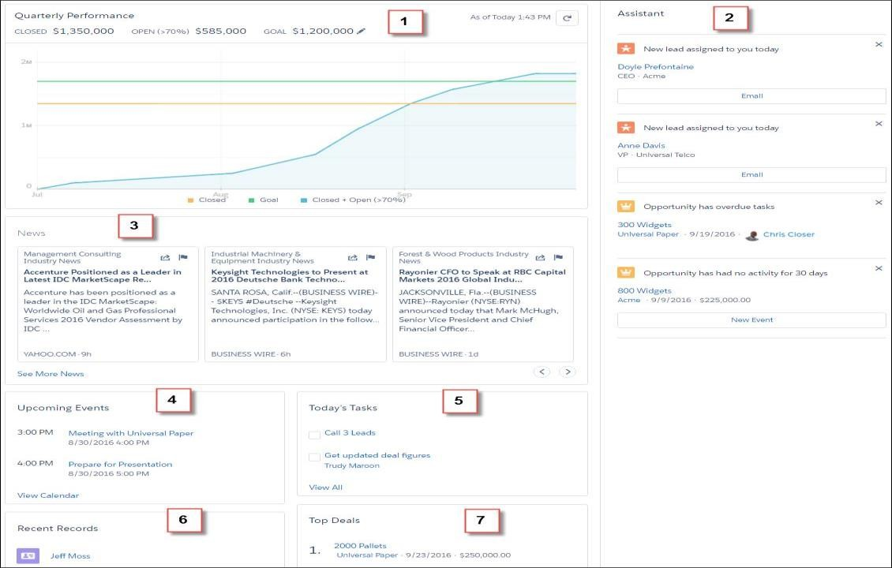

1. Enter your username and password and click Log in to Salesforce .

Once you’re logged into Salesforce, you’ll be directed to Home. Let’s talk about that first.

## Home

Home is the first place you’ll land when you log into Salesforce. It’s a modern, intelligent home page, featuring a number of tools to help you start your day fast. From Home, you can monitor your performance to goal and get insights on key accounts. You can also access the Assistant, a list of things to do and places to be. Your Salesforce admin can create custom Home pages that appear for different profiles, so you may see different features on your Home page.

* Use the Assistant to identify exactly what you need to be doing today
* Use the Performance Chart to monitor how close you are to crushing your number
* Get insights fast with News
* Focus your selling activities on your Top Deals

1. Performance Chart: Monitor and update your performance to goal.

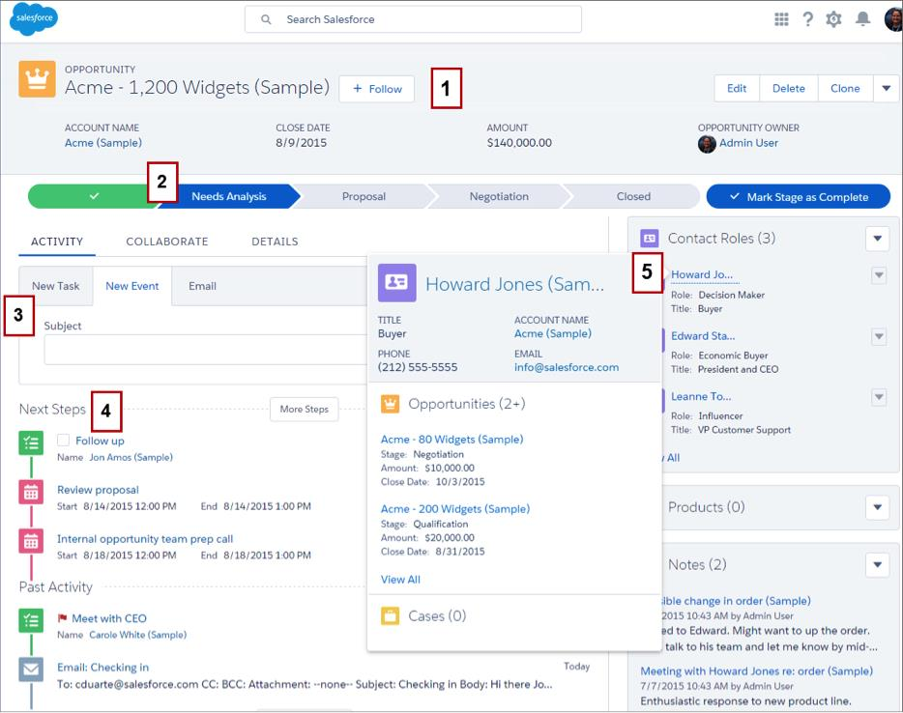

1. Assistant: Stay on track by seeing the leads and opportunities that require your attention.
2. News: Get insights at a glance on your important accounts.
3. Upcoming events: See the next five meetings on your calendar today.
4. Today’s tasks: See up to five tasks due today.
5. Recent records: Access links to recently viewed records.
6. Top deals: View your top open opportunities in a convenient list.

## Opportunity Workspace

If you remember the definitions that we reviewed in the previous unit, opportunities are leads that are qualified to buy. Whether you’re coming from Home, the navigation menu, Search, or a related record in Salesforce, once you click on an opportunity, you need a powerful workspace where you can get stuff done quickly and focus your energy on selling.Enter the opportunity workspace. Here, your sales process takes center stage, with customized coaching scripts for each stage in the sales process, at-a-glance insights and activity timeline, and the ability to create records quickly with fewer clicks.

1. Highlights Panel: See important information right at the top of the record.

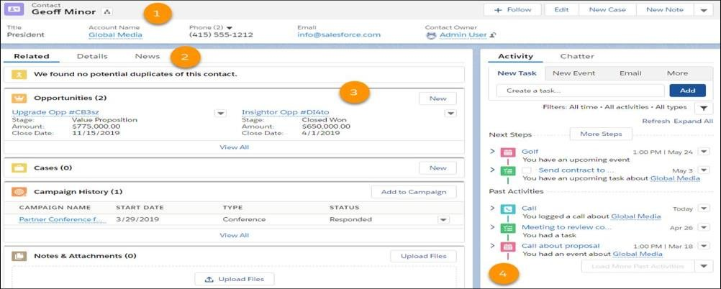

1. Path: Access customized guidance for each stage in your sales process.
2. Composer: Quickly log a call, create a task, or send an email.
3. Activity Timeline: View emails, tasks, and events, grouped by your next steps and past activity.
4. Quick View: Hover over any linked record to see details without having to leave the page.

## Accounts and Contacts

Remember that when a lead is converted, an account and contact are also created in Salesforce. An account is a company you’re doing business with, and a contact is someone who works at that account. Just like opportunities, anytime you drill into an account or contact, you need to find what you need quickly. But unlike opportunities, you’re less likely to need to make updates. Instead, we’ve optimized the layout for these pages for quick reference, allowing you to find information and gather insight at-a- glance.

* Get the latest news about your customers with integrated Twitter and News
* Work smarter and keep your data clean with field-level duplicate matching
* Locate important data efficiently with layout designed specifically for quick reference
* Review past and upcoming activities at a glance

1. Highlights Panel: See important information right at the top of the record.

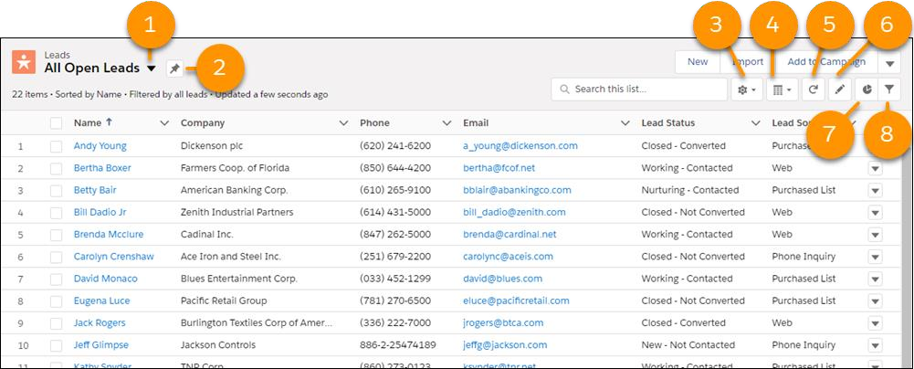

1. News and Twitter Integration: Stay informed about the latest news that affects your customers and stay connected through social media.
2. Optimized template: Easy reference to related records and at-a-glance information.
3. Activity Timeline: View emails, tasks, and events, grouped by your next steps and past activity.

## List Views

List views let you see records that are important to you. Using filters, you can create customized lists of accounts, contacts, opportunities, or other records in Salesforce. For example, create a list view of opportunities you own and add a filter on amount to help you find your biggest deals in the pipeline.

List views are more than just columns of text. Power up your productivity with list view charts to visualize your data graphically with a handy chart. And it’s all created on the fly without an admin’s help.

* Visualize data in seconds with list view charts
* Quickly slice your data how you want by creating filters on the fly
* Find a favorite list view fast with type-ahead search



List View dropdown menu (1) Click to access your list views. Pin list icon (2) Click to pin a list view. A pinned list is the default list view for that object. A icon indicates a pinned list. To pin a different list, select a different list view and pin it instead. List View Controls menu (3) Click to access list view actions, including creating, renaming, cloning, and sharing them. You can also choose which fields to show in a list and editing filters that you’ve applied. Layouts icon (4) Click to toggle between displaying lists in the standard table view ( ) or the Kanban view ( ). The icon changes to match the selected view. Kanban is a workflow visualization tool. We talk about Kanban in a bit. When working with task lists, you can also use split view ( ) to see all of your tasks on the left side of the page, plus the details for a selected task on the right. Refresh icon (5) Click to get a fresh view of a list more quickly than doing a full page reload. Edit icon (6) Click to update fields in your list. You move to the first editable field in the list. Edited fields are highlighted in yellow to remind you to save your changes. Charts icon (7) Click to transform list data into simple and easy-to- understand pictures that show things like percentages, totals per account, ratio of dog lovers to cat owners, and other useful information. Filter icon (8) Click to narrow or expand the records that appear in a list view by adding, modifying, or removing filters.

## The Kanban View

The Kanban view organizes a set of records into columns to track your work at a glance. To update a record’s status, drag it into a different column. You can configure the board by selecting what fields columns and summaries are based on. And, get personalized alerts on key opportunities in flight.

* Visualize your work at each stage or status
* Move records between columns using drag and drop functionality
* Configure columns and summary fields on the fly
* Edit or delete records to keep them up to date

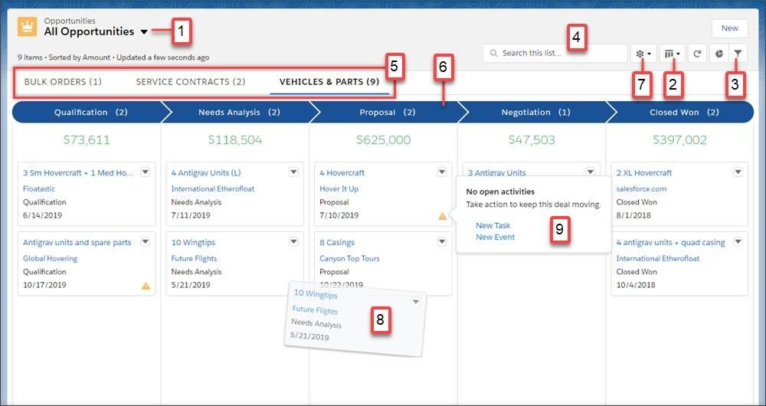

* Quickly create filters to slice your data how you want
* For opportunities, get alerts to notify you when action is needed on a key deal

1. The records in the Kanban view are based on the selected list view.
2. Easily toggle between the list view grid view and the Kanban view.
3. Filter your records to view a particular subset of your records.
4. Search for records within the current view.
5. Select which record type to view.
6. Columns are created based on the grouping field.
7. Change how columns are organized and summarized using Kanban settings.
8. Quickly move a record to a different column by dragging the card.
9. For opportunities, alerts tell how to keep a deal on track, for example, create a task or event.

## Reports and Dashboards

Similar to list views, reports are a list of records that meet the criteria you define. But unlike list views, with reports you can apply more complex filtering logic, summarize and group your data, perform calculations, and create more sophisticated visualizations of your data using dashboards.

One feature you’ll love is the ability to create your own filters on the fly. Dashboards created by your admin highlight the data you need in a flexible layout, with spanning columns so you can see more dashboard components (charts) in different sizes on a single dashboard.

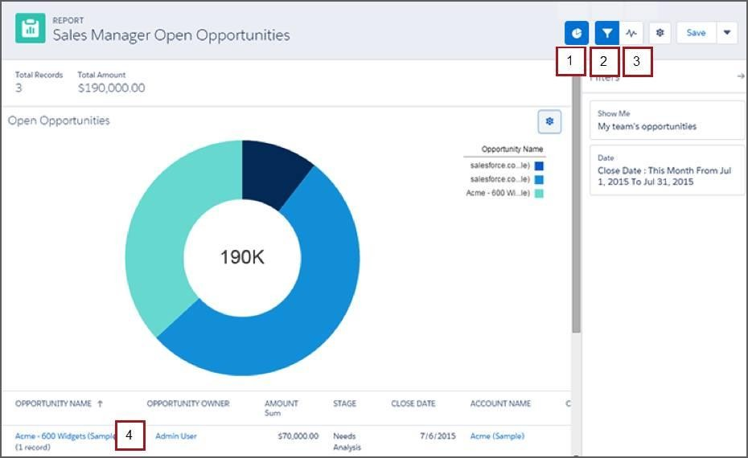

* Create filters on the fly for reports
* Make visually awesome dashboards using flexible layout and spanning columns
* Collaborate with others via feeds

1. Report Charts: Create a quick visualization of your data on demand.
2. Filters: Add a filter on the fly to slice data as needed.
3. Feeds: Collaborate on report data.
4. Simple Layout: Add the columns you want to see and sort them as needed.

The [preconfigured dashboards](https://appexchange.salesforce.com/appxListingDetail?listingId=a0N3A00000FMkREUA1) managed package provides ready-to-use dashboards and reports for executive sponsors, managers, and sales reps.

## Search for Records

With all the useful data you have in Salesforce, search is the quickest way to find what you need, when you need it. In Lightning Experience, you can search from the top of every page.

This video guides you through searching in Lightning Experience and navigating search results.

## What to Do If You Don’t Find What You’re Searching For

* Check your spelling and verify that you entered the full search term.
* Check whether the object or field is searchable.
* Make sure you have access to the record. Search only returns results you have permission to view.
* If you recently created or updated the record, wait a few minutes for the record to be made searchable. If you can’t find your record after 15 minutes, contact your admin.

## Other Rad Stuff

Check out these additional features.

* Navigate through pages with ease using the space-saving, collapsible left navigation menu.
* Take notes easily with the notes tool, which includes autosave, rich text capabilities, and the ability to relate a note to multiple records.
* Switch between user accounts or between orgs from the profile menu.

## What About Salesforce Classic?

We’ve focused on Lightning Experience because it’s where all new Salesforce innovation happens. But Salesforce Classic is still available too.

On the surface, Salesforce Classic and Lightning Experience look somewhat similar, but as we’ll see later on, looks can be deceiving.

|  |  |
| --- | --- |
| **Icons in the top-right means you’re in**  **Lightning Experience** | **The app menu in the top-right means**  **you’re in Salesforce Classic** |
|  |  |

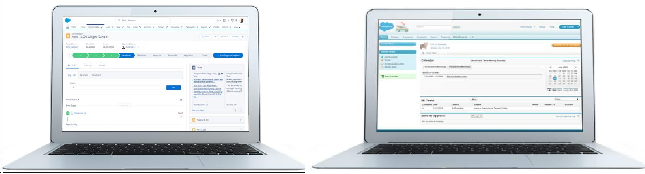Many Lightning Experience enhancements aren’t available in Salesforce Classic and a few features available in Salesforce Classic aren’t yet supported in Lightning Experience. For this reason, you can move between Lightning Experience and Salesforce Classic as needed.

You might discover this on your own if you see something called the Switcher in Salesforce, so let’s take a moment here to explain how this works.

# AFTERNOON SESSION DETAILS

|  |  |  |  |
| --- | --- | --- | --- |
| **Date:** | **18-7-2020** | **Name:** | **Gaganashree P** |
| **Course:** | **coursera** | **USN:** | **4al15ec024** |
| **Topic:** | **Computer vision basics** | **Semester & Section:** | **8th A** |
| **Github Repository:** | **Gaganashree-P** |  |  |

|  |
| --- |
| Image of session |
| **COMPUTER VISION BASICS**  **What is a computer vision basics?**  Computer vision is a field of study which enables computers to replicate the human visual system. It’s a subset of artificial intelligence which collects information  from digital images or videos and processes them to define the attributes. The entire |

process involves image acquiring, screening, analysing, identifying and extracting information. This extensive processing helps computers to understand any visual content and act on it accordingly.

Computer vision projects translate digital visual content into explicit descriptions to gather multi-dimensional data. This data is then turned into computer-readable language to aid the decision-making process. The main objective of this branch of artificial intelligence is to teach machines to collect information from pixels.

Computer Vision primarily relies on pattern recognition techniques to self-train and understand visual data. The wide availability of data and the willingness of companies to share them has made it possible for deep learning experts to use this data to make the process more accurate and fast.

While machine learning algorithms were previously used for computer vision applications, now deep learning methods have evolved as a better solution for this domain. For instance, machine learning techniques require a humongous amount of data and active human monitoring in the initial phase monitoring to ensure that the results are as accurate as possible. Deep learning on the other hand, relies on neural networks, and uses examples for problem solving. It self-learns by using labeled data to recognise common patterns in the examples.

## Which language is best suited for computer vision?

We have several programming language choices for computer vision – OpenCV using C++, OpenCV using Python, or MATLAB. However, most engineers have a personal favourite, depending on the task they perform. Beginners often pick OpenCV with Python for its flexibility. It’s a language most programmers are familiar with, and owing to its versatility is very popular among developers.

Computer vision experts recommend Python for the following reasons:

* Easy to Use: Python is easy to learn, especially for beginners. It is one of the first programming languages learnt by most users. This language is also easily adaptable for all kinds of programming needs.
* Most Used computing language: Python offers a complete learning environment for people who want to use it for various kinds of Computer Vision and Machine Learning experiments. Its numpy, scikit-learn, matplotlib and OpenCV provides an exhaustive resource for any computer vision applications.
* Debugging and Visualisation: Python has an in-built debugger, ‘PDB’ which makes debugging codes in this programming language more accessible. Similarly, Matplotlib is a convenient resource for visualisation.
* Web Backend Development: Frameworks like Django, Flask, and Web2py are excellent web page builders. Python is compatible with these frameworks and can be easily tweaked to fit your requirements. MATLAB is the other programming language popular with computer experts. Let’s look into the advantages of using MATLAB:
* Toolboxes: MATLAB has one the most exhaustive toolboxes; whether it is a statistical and machine learning toolbox, or an image processing toolbox, MATLAB has one included for all kinds of needs. The clean interfaces of each of these toolboxes enables you to implement a range of algorithms. MATLAB also has an optimisation toolbox which ensures that all algorithms perform at their best.
* Powerful Matrix Library: Images and other visual content contains multi- dimensional matrices along with linear algebra in different algorithms which becomes easier to work within MATLAB. The linear algebra routines included in MATLAB work fast and effective.
* Debugging and Visualisation: Since there is a single integrated platform for coding in MATLAB, writing, visualising and debugging codes become easy.
* Excellent Documentation: MATLAB enables you to document your work adequately so that it is accessible later. Documentation is essential not just for future

reference but also to help coders work faster. MATLAB’s documentation allows users to work twice the speed of OpenCV.

## Computer Vision experts also gravitate towards OpenCV for the following reasons:

* Zero Cost: OpenCV comes at free of cost and what’s better than saving a little money? You can use it for commercial applications, even check the source for corrections. The most significant advantage of using OpenCV is that you don’t have to make your project open source.
* Exhaustive Library: OpenCV has the most extensive collection of algorithms. The transparent API makes OpenCL devices compliant on devices and optimises performance.
* Platform and Devices: A number of embedded vision applications and mobile apps prefer OpenCV as their vision library of choice for its performance-focused design. You can use it across all platforms and devices.
* Large Community: OpenCV is used by over 9 million people who are continually updating and helping each other through blogs and forums. A significant advantage of using OpenCV is that you will always find support from the community. Since companies like Google, Intel and AMD fund its development, OpenCV is evolving fast.

## Applications of Computer Vision

* Medical Imaging: Computer vision helps in MRI reconstruction, automatic pathology, diagnosis, machine aided surgeries and more.
* AR/VR: Object occlusion (dense depth estimation), outside-in tracking, inside-out tracking for virtual and augmented reality.
* Smartphones: All the photo filters (including animation filters on social media), QR code scanners, panorama construction, Computational photography, face detectors,

image detectors (Google Lens, Night Sight) that you use are computer vision applications.

* Internet: Image search, geolocalisation, image captioning, ariel imaging for maps, video categorisation and more.

# Using algorithms

Arithmetic optimization and the Linux Framebuffer

Using the framebuffer, the chapter described a floating-point implementation of affine image transformation and characterized its performance on the Raspberry Pi’s ARM11 processor. While the latency of the floating-point instructions can be hidden using independent operations on other pixels, the overhead required to convert pixel indices from integers to floating-point values and back to integers resulted in a large number of instructions required per pixel.

To overcome this problem, the chapter introduced fixed-point representation and arithmetic. Fixed-point arithmetic gives the programmer access to fractional number arithmetic using integer instructions and without using floating point. Fixed point is available to applications that have a narrow, predefined numerical range.

The chapter described the accuracy, range, and precision of fixed-point values as compared to floating point. In order to explore the practical aspects of fixed point, the chapter showed example macros for fixed-point addition and multiplication, written in both high-level language and inline assembly code.

Using these macros as examples, the chapter demonstrated how using inline assembly language allows the programmer to exploit architectural features useful in fixed-point arithmetic that are not available to the C-language code. An example of this is taking advantage of the status register to capture the last shifted-out bit to implement rounding.

After this, the chapter described how to convert the image transformation example from floating point to fixed point. This provided a 40% improvement to performance by reducing the number of instructions per pixel.

As another example of a computationally expensive graphical application, the chapter introduced Mandelbrot set generation. Although the Mandelbrot set has few practical applications, it serves as a benchmark for a compute- and arithmetically intensive program, and has the advantage that speeding up the application produces a visible improvement in frames per second as the images as rendered in real time on an attached monitor.

The Mandelbrot set is also amenable to fixed-point arithmetic but requires careful selection of radix point location in order to maintain sufficient range and maximize precision. The behavior of the Mandelbrot set, in terms of the number of zoom levels, is determined to the amount of precision in the intermediate data types. This makes fixed- point arithmetic, being amenable to multi-precise integer arithmetic, even more attractive for this application.

The next chapter covers the Video4Linux subsystem, which allows us to capture video frames from an attached camera for processing with computer vision algorithms. This chapter’s optimization strategy is memory optimization through loop transformation.

## Exercises

1. Write a fixed-point implementation of the Mandelbrot generator.

a.You will notice that the performance is inconsistent between different pixels and different frames. Why is this?

b.What is the arithmetic intensity of the innermost loop body, in operations per byte accessed from memory? What is the corresponding performance bound for your ARM CPU? How does it compare to your observed performance?

c.Measure the following performance metrics for the innermost loop body:

* instructions per iteration
* instructions per operation
* CPI
* cache miss rate

d.Use inline assembly to implement the innermost loop body and measure the performance impact with respect to the metrics from part c. What is the speedup as compared to the compiler-generated code?

1. Parallelize the Mandelbrot set generator using OpenMP. Apply the parallel-for directive to the outer-most (row) loop.

a.Measure the average number of cycles required for each iteration of the innermost loop (to evaluate the polynomial) for one thread and two threads for the initial frame. Use these measurements to calculate the speedup, in terms of pixels per second, of two threads over one thread.

b.Measure the time to compute all the pixels in the first frame when using the dynamic schedule as compare to the static schedule.

1. What makes it difficult to apply SIMD operation for the Mandelbrot set generator? What is the most efficient method for applying SIMD operation for the Mandelbrot set generator?
2. Measure the effective write throughput for the Linux Framebuffer. Is it equivalent to the write throughput for a memory array allocated from the heap?
3. Calculate the arithmetic intensity of the image transformation program in operations per pixel. What is its performance bound given the effective memory throughput of your ARM CPU? How does it compare to your observed performance?
4. Use OpenMP to add multicore support to the fixed-point image transformation program. To do this, apply the parallel for pragma to the outer-most (row) loop.

Measure its performance on a four-core ARM CPU. How does its performance scale when executed with one, two, three, and four threads?

1. Use intrinsics to add NEON SIMD support to the fixed-point version of the image transformation program. Use four-way operations to compute the following calculations for a group of four pixels: source pixel location, fraction extraction, and weight calculation. To what degree does this improve performance?
2. We cannot easily optimize the Mandelbrot generator program using SIMD instructions, since neighboring pixels may require a different number of polynomial evaluations and each iteration of the polynomial is dependent on the previous evaluation. An alternative approach is to implement the loop in inline assembly, unroll by at least four, and then use software pipelining to improve loop CPI. In this case, we should avoid conditional branches inside the unrolled loop. Since diverging c-values will continue to diverge with subsequent evaluations, we can wait to check the loop exit condition after each group of four iterations. However, performing additional polynomial evaluations after a Pc() potentially diverges outside the radius-2 circle will require us to account for the additional range requirements for our fixed-point format. Recalculate the fixed-point range requirements for this optimization and determine to what degree this will reduce the maximum zoom level.
3. The principle advantages of fixed point are the reduction in operation latency and the ability to avoid type conversions in certain types of graphics codes. Chapter 2 highlights an example program whose performance is sensitive to operation latency, Horner’s method. Assuming that we can tolerate the range limitations of fixed point in our Horner’s method code, would converting it to fixed-point improve performance? Explain your answer.

It showed two different implementations of a generalized fixed-point addition preprocessor macro. The first was generated by gcc under maximum optimization, the second was hand coded using inline assembly language. Both implementation required approximately the same number of instructions.